**Setup Outlook account**

1. Create a new outlook account
2. Navigate to Setting > view all outlook settings > Mail > Sync email
3. Enable POP settings

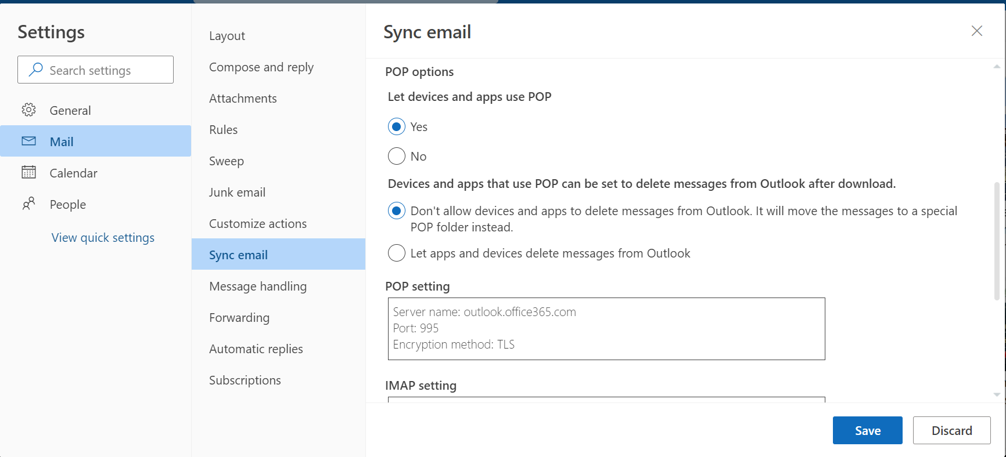

**Create Email account in ServiceNow**

1. Navigate to email accounts in ServiceNow and create new.

**Email Client Configuration**

1. Navigate to Email Client Configuration and create a new record for Incident

Email Client Template

1. Create a new Client Template



